Advertisement Project
8th Grade FACS
Directions: Your assignment, as the marketing department for a manufacturer, such as General Mills, Kellogs, Lysol, Nabisco, Bryers is to design an advertisement for a new product.
You will need to meet the following requirements:

- The design needs to appeal to 3-9 year olds. They are your target customer age group. Makes sure the is advertisement appropriate? (4 pts)
- The design needs to use eye-catching colors (5 pts)
  - Think: what are children 3-9 interested in? What colors make them attracted to different products?
- The design uses a character to promote the product (3 pts)
  - Animals: bugs, etc. Advertisers don’t usually use bugs to promote food, but some kids like it.
  - Superheroes: Little kids prefer fantasy characters to pictures of real people
  - Stars: Celebrities appeal to both boys and girls and putting stars on boxes is one of the most effective ways to sell cereals.
- The design has a clever and easy name to remember (3 pts)
- The design uses an appealing description for the product (4 pts)
  - What is the product? What is it made out of (oats, grahams, corn, rice, etc), are they colorful, are they in different shapes, sizes flavors? Be SPECIFIC!
- The design must use one of the advertising techniques we discussed in class (4pts)
  - Examples: Humor, Celebrity Endorsement, Lifestyle, Happy times, etc.
  - There should be a written description on the back of the advertisement explaining what advertising technique is used and how it is being used

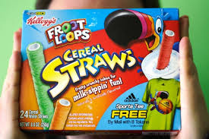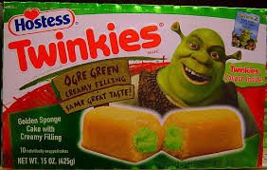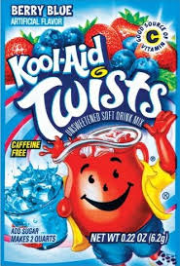

Advertisement Design
Rubric

Creative Team Member(s):
 | Earned: | Possible:
Neat without the use of pen/pencil -- Uses a variety of colors to catch the attention of children. |  | 5
Does it appeal to 3-7 year olds? Is it appropriate? |  | 4
Uses a character to promote the product |  | 3
Has a clever and easy name to remember |  | 3
Uses an appealing/specific detailed description for the product |  | 4
Paragraph explaining advertising technique used/how it’s used |  | 4
Spelling/Grammar |  | 2
Total: |  | 25

Advertisement Design
Rubric

Creative Team Member(s):
 | Earned: | Possible:
Neat without the use of pen/pencil -- Uses a variety of colors to catch the attention of children. |  | 5
Does it appeal to 3-7 year olds? Is it appropriate? |  | 4
Uses a character to promote the product |  | 3
Has a clever and easy name to remember |  | 3
Uses an appealing/specific detailed description for the product |  | 4
Paragraph explaining advertising technique used/how it’s used |  | 4
Spelling/Grammar |  | 2
Total: |  | 25

