Quesadillas!
Ingredients:
Tortillas
Cheese
Pepperoni (if wanted)

Directions:
- Turn the burner on a medium heat.
- When the skillet is warm, put 1 tortilla in the skillet. Leave it there for about 1 minute or less to warm up.
- After about 1 minute, flip the tortilla so it is on the other side.
- Sprinkle some cheese on only half of the tortilla and flip the other half over the cheese. It should look like a sandwich with cheese in the middle.
- Let it sit there for about 1 minute. Then flip the quesadilla over to the other side to warm the other side.
- When the cheese looks melted, take it off the skillet and put it on a plate to cool down.
- Once the tortilla is cooled down, cut it down into pieces, and eat it!

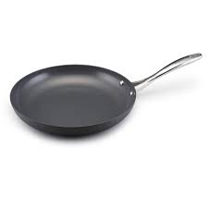
^^^^ Skillet ^^^^

