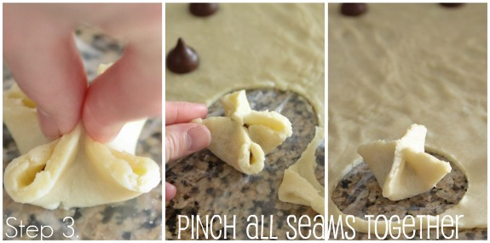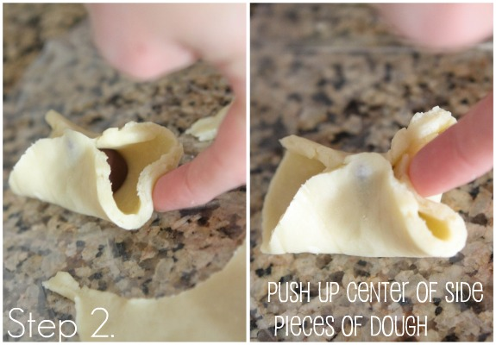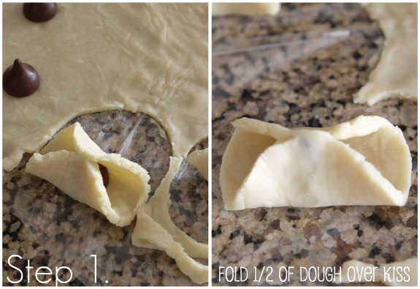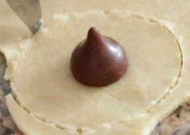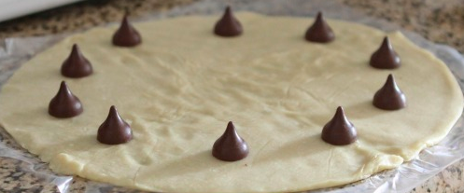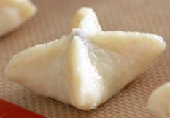

2-Ingredient Hershey Kiss Pie

***Ingredients:***

12 Hershey Kisses

1 Roll Out Pie crust

2 T. Egg Substitute

2 T. Sugar

Powdered Sugar for dusting

***Directions:***

1. Preheat the oven to 350º
2. Unroll the pie crust
3. Place the Hershey Kisses around the pie crust
4. Using a knife, cut a 3 inch circle around each Hershey kiss.
5. Follow directions in the photo below for folding dough/kiss
6. Follow directions in the photo below for folding Hershey Kiss
7. Brush egg wash over each little pie.
8. Sprinkle with sugar
9. Place on a ***parchment paper lined*** cookie sheet
10. Bake for 20-28 minutes or until golden brown
11. Dust with powdered sugar

Eat and Enjoy!