Pizza Quesadillas!
Ingredients:
1 Tortillas (per person)
1 Tbsp Marinara Sauce (per person)
1 cup Cheese (per group)
Toppings (optional)
Teacher Notes:
- Cooking Spray

Directions:
- Turn the burner on a medium heat.
- When the skillet is warm, put 1 tortilla in the skillet. Leave it there for about 1 minute or less to warm up.
- After about 1 minute, flip the tortilla so it is on the other side.
- Put 1 spoonful of marinara sauce on HALF the tortilla, sprinkle cheese on top of the marinara sauce, along with your pizza toppings and Italian seasonings.
- Fold the tortilla in half so it looks like a pizza sandwich.
- Let it sit there for about 1 minute. Then flip the quesadilla over to the other side to warm the other side.
- When the cheese looks melted, take it off the skillet and put it on a plate to cool down.
- Once cooled, eat and enjoy!

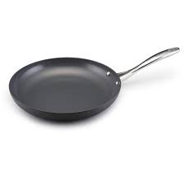
^^^^ Skillet ^^^^

